**Lab# Log Analytics Workspace and Microsoft defender**

1. **Screenshot of successful VM created:**

1. **Screenshot of successful log analytics workspace:**

1. **Screenshot of successful created azure storage account:**

1. **Screenshot of successful created data collection rule:**

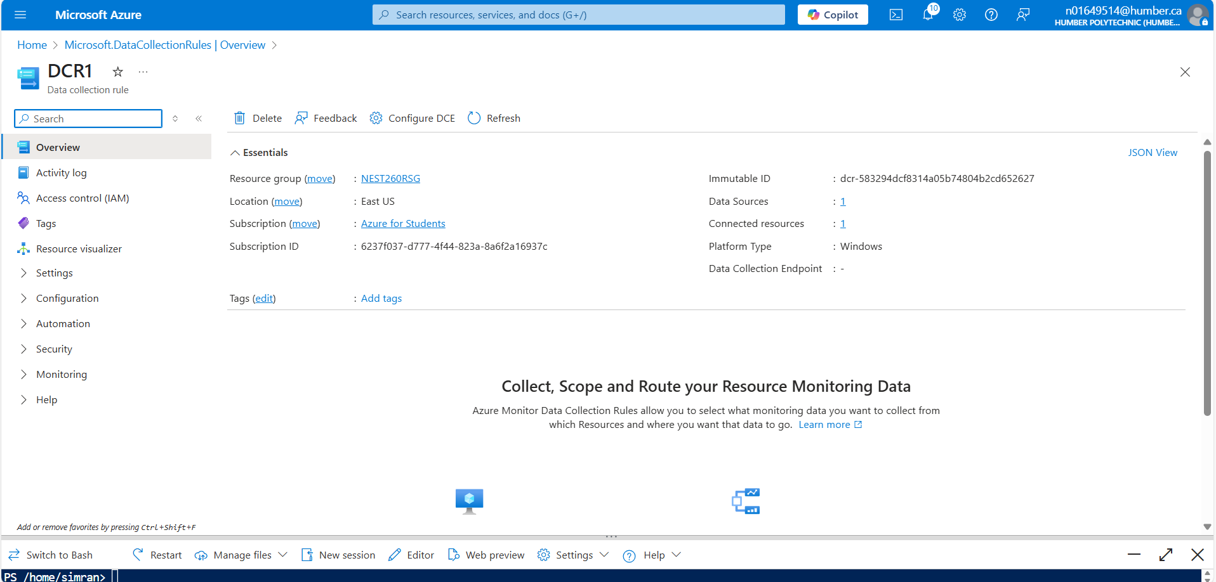

1. **Screenshot of successful configuring Microsoft defender for cloud enhanced security features for servers:**

1. **Screenshot of successful created VM i.e. nest260vm**

